Noah Smith

CIS 310-02

9/10/2019

Week 4 Homework

Pg: 153 #21. 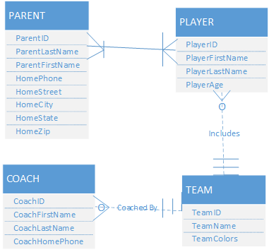

Pg: 154 # 1.

